Energy Generation trends from 2001-2021

Covering the Contiguous United States

Dan Rausch

Data Visualization 44-613

2024 Spring OP Block 1

Dr. Case, Denise

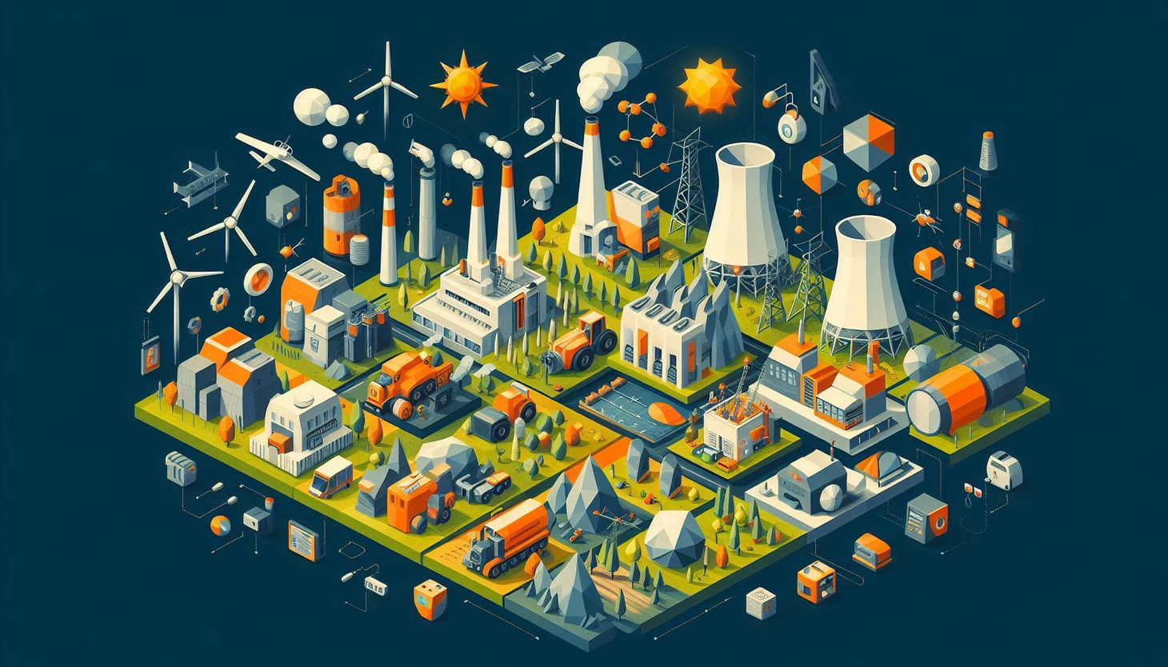

*Image created by ChatGPT – Asked to generate a collage based on the primary energy generation types in the United States in 2021.*

Section 1. Introduction 3

Section 2. Data Description 3

Section 3. Data Cleaning Strategies 4

Section 4. Clean Dataset 5

Section 5. Visualization Tools 6

Section 6. Visualizations and Stories 7

*Goal 1: What is the distribution of energy generation types in the US from 2001 to 2021?* 7

*Goal 2: What is the primary generation type by state in 2001 and how does that change in 2021?* 8

*Goal 3: How does population impact total MWh’s generated in 2021?* 10

*Goal 4: What is the distribution of energy generation by US region in 2021?* 11

*Goal 5: What is the distribution of average Retail Price for a kWh by region?* 12

*Goal 6: Based on 20 year history, what is the energy generation forecast from 2021 to 2024?* 13

Section 7. Conclusions 14

# Section 1. Introduction

This project looks at historical energy generation statistics by state and by type of power in order to help the reader draw conclusions about the overall progress of energy generation and which fuels are most prevalent. The concept of cost of generation and retail cost for consumer by state is also explored to help create a comprehensive view of US energy generation and consumption both relatively currently as well as historically. This report would be useful for state and federal lawmakers, energy investors, or certain energy advocates as it provides a comprehensive view of state and national trends in types of fuel consumed, forecasted generation trends, state populations, and regional retail pricing.

# Section 2. Data Description

|  |  |
| --- | --- |
| **Data Domain** | **Description** |
| **Description** | Energy and Population; Fuel generation, retail, population, and consumption by State for the contiguous United States |
| **Data Source** | **Description** |
| **Source 1: Kaggle** | https://www.kaggle.com/datasets/kevinmorgado/us-energy-generation-2001-2022 |
| **Source 2: Census.gov** | <https://www2.census.gov/programs-surveys/popest/tables/2020-2022/state/totals/NST-EST2022-POP.xlsx> |
| **Source 3: EIA State Archives** | <https://www.eia.gov/electricity/state/archive/2021/> |
|  | Combined these three sources into two Tableau data sources (below) |
| **Column/Row Details** | **Description** |
| **Final Project Data** | **12 fields, 49 rows** |
| **Raw_Generation_Data** | **8 fields, 107,292 rows** |
|  | Data relationship established via State field |
| **Column / Field Details** | **Description** |
| **Final Project Data** |  |
| State | Location - State within the United States |
| State Abbrv | Abbreviated Location used for combining data |
| Geographic Region | Associated Region per Census.gov |
| 2021 Population (Est.) | Estimated Population in the State per Census.gov |
| 2021 Primary | Type of Primary power generation in 2021 |
| 2021% | % of Primary power generation versus total in 2021 |
| 2021 Primary | 2021 Primary power generation in MWh |
| 2001% | 2021 Percentage of Total Power generation |
| 2001 Primary | 2021 Type of Primary power generation |
| Retail Price Range | 2021 Primary power generation in MWh |
| Avg Retail Price (cents/kWh) | Average Retail price of a kWh of electricty in cents in 2021 |
| Net generation (MWh) | Total Net Generation (MWh) in 2021 |
| Total Retail Sales (MWh) | Total Retail Sales of Electricity (MWh) in 2021 |
| **Raw_Generation_Data** |  |
| Year | Year of Energy Production |
| Month | Month of Energy Production |
| Date | Calculated field derived from Year and Month |
| State1 | State where energy was produced |
| Type of Producer | Total Electric Power Industry |
| Energy Source | Type of Fuel used (e.g. Coal, Nuclear, Hydro, Wind) |
| Generation (Megawatthours) | Amount of Megawatthours produced (referred to as MWh) |
| Energy Source (group) | Grouping to combine low energy source production |

# Section 3. Data Cleaning Strategies

FinalProjectData Source:

* Normalize the State field. Some used abbreviations while others used state names.
* Add geographic area from Census.gov (<https://www2.census.gov/geo/pdfs/maps-data/maps/reference/us_regdiv.pdf>)
* Removed Hawaii and Alaska as this report focuses only on Contiguous United States

Raw_Generation_Data Source:

* Created Energy Source (Group) to combine little used power generation fuel methods
* Created Calculated field Date combining Year and Month
* Removed Negative Generation Values as this reflects facility use of generation per EIA
* Removed 2022 data as it only contained data through May 2022
* Removed Hawaii and Alaska as this report focuses only on Contiguous United States
* Removed US-TOTAL from State Field as it caused duplication of data
* Removed TOTAL from Energy Source Field as it caused duplication of data
* Retained only TYPE OF PRODUCER = “Total Electric Power Industry” as it represented the total volume of production for the state and type of producer.

# Section 4. Clean Dataset

This is representative of the data used in the Tableau project. It reflects the above referenced data fields as well as the steps taken to clean the data.

**FinalProjectData:**



**Raw_Generation_Data**



# Section 5. Visualization Tools

Tableau for visualizations. My primary focus was to learn about how to build visualizations in Tableau. It was the best for the geographic information, interactivity, and use of the analytics module.

Excel for data consolidation. Moving from three files to two and adding in state geographical data was much easier to accomplish in Excel.

Link to Github with Working Files: <https://github.com/s545773/DATA-VIZ-808182SP24/wiki>

Link to Tableau Public: <https://public.tableau.com/views/Rausch_Mod7FinalProject/Goal1WhatisthedistributionofenergygenerationtypesintheUSfrom2001to2021?:language=en-US&:sid=&:display_count=n&:origin=viz_share_link>

# Section 6. Visualizations and Stories

### *Goal 1: What is the distribution of energy generation types in the US from 2001 to 2021?*



### *Goal 2: What is the primary generation type by state in 2001 and how does that change in 2021?*





### *Goal 3: How does population impact total MWh’s generated in 2021?*





**

### *Goal 4: What is the distribution of energy generation by US region in 2021?*



### *Goal 5: What is the distribution of average Retail Price for a kWh by region?*



### *Goal 6: Based on 20 year history, what is the energy generation forecast from 2021 to 2024?*



# Section 7. Conclusions

This analysis reveals that the United States is undergoing a significant transformation in how it’s overall energy is generated. While Coal is making a comeback in 2021, the prevailing direction is moving towards Natural Gas and Wind/Solar. The energy grids of the United States are moving towards more efficient forms of energy production.

Another major conclusion is that when there are not as much generation methods in the state, thent he cost for energy is higher. That is evidenced by the Northeast region and California being dependent on others for their energy production.

Some key additional areas for investigation were a review of the total amount of kilowatt hours generated in the US – it hasn’t significantly grown in the last 20 years. Is that a problem with the data set or is this indicative of reality. What is the rational for this? More energy efficiency in consumer, commercial, and industrial products?